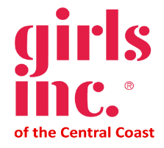

Donate new and gently used handbags to Support
Girls Inc. of the Central Coast

Girls Inc. of the Central Coast is pleased to announce our fall fundraiser: Bubbles and Bags. The live virtual auction will take place on Sunday, November 15, 2020. Girls Inc. of the Central Coast delivers innovative, research-based programs designed specifically to address the strengths and needs of girls ages 8-18 and to prepare them for economic independence and confident adulthood. For more details about the organization, please view the following link: http://www.girlsinccc.org
Last year more than 500 handbags were donated to the event. Our goal for 2020 is to focus on quality and design, but we need your help! We are collecting handbags NOW and will do so until Friday, October 23, 2020. We hope that you and your friends have good quality handbags that you would like to donate to the cause. We are looking for:

- “Like New” handbags that no longer suit your taste
- New bags you have never used
- High-end/Designer bags
- Every day and evening bags
- Wallets in very good condition

Enclosed is a donation form. Please complete the form and place one inside each bag you donate.
We have two bag donation drop off locations:
Fenton & Keller  2801 Monterey-Salinas Highway  Monterey, CA 93940  (831) 373-1241 | Girls Inc. of the Central Coast Office  318 Cayuga St. Suite 206  Salinas, CA 93901  For more information or to schedule a pick-up,  Call our office at (831) 772-0882

Join us for the event and shop for a great cause! Sip champagne, socialize and purchase some fabulous handbags to add to your collection or to give as holiday gifts*.

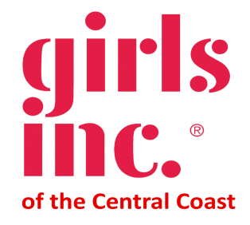

BUBBLES AND BAGS Donation Form
Auction Date: Sunday, November 15, 2020

Girls Inc. of the Central Coast acknowledges your participation in the Bubbles and Bags Auction. Your contribution is tax deductible to the extent allowed by law.
(Please Fill Out Completely)
Donated Item: ________________________________________________________
Donor’s Name: _________________________________________________________
Address: ______________________________________________________________
City: ______________________________ State: ____ Zip: _________
Day Phone #: ____________________ FAX: ________________________
Email: _________________________ Cell: ______________________________

Complete Description: (Include all facts for auction program description and publicity; e.g., brand, unusual aspects, rarity, size, color, etc.).

Retail Value of Donation: $___________________
For cash donations, please make checks payable to Girls Inc. of the Central Coast and mail with this form to: Girls Inc. of the Central Coast 318 Cayuga St, Suite 206, Salinas, CA 93901
Donor Signature: _________________________________Date: _______________________
BAG DONATION locations: Fenton & Keller, 2801 Monterey-Salinas Highway, Monterey, CA 93940 (831) 373-1241. The Salinas donation location is the Girls Inc. of the Central Coast office at 318 Cayuga St, Suite 206, Salinas, CA 93901. For more information or to schedule a pick-up, call (831) 772-0882.
Deadline for donating bags is Friday, October 23, 2020.

Thank you for your donation. Please understand that once your donation is submitted, the item(s) you donated cannot be returned to you because you are provided a charitable tax deduction as soon as your donation is made. While it is our expectation that all donations will be used at this year’s event, if your item does not sell we may use your donation at a subsequent Girls Inc. event. We truly appreciate your support and thank you for your understanding.

