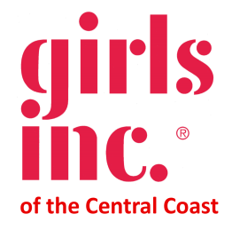

Sponsorship Opportunities

2020 Girls Inc. of the Central Coast Bubbles and Bags
Sunday, November 15, 2020

Girls Inc. of the Central Coast (GICC) is pleased to announce our fall fundraiser: Bubbles and Bags to be held on Sunday, November 15, 2020 in a fun virtual live auction! Your participation is needed more than ever as we navigate through difficult times. Your support will provide the necessary resources to continue to provide much needed services to our girls.

We offer a variety of sponsorship levels that will provide high visibility at this popular event. Funds raised will support programs that improve the lives of girls throughout our community. All funds raised at the Bubbles & Bags event benefit local girls in Monterey, San Benito, and Santa Cruz Counties.

Our programs challenge girls to explore their potential, prepare to attend college, build fulfilling careers and expand their sense of what is possible.

GICC is an affiliate of Girls Incorporated, a national organization that has been providing programs for girls since 1864 in the United States and Canada. GICC delivers innovative, research-based programs designed specifically to address the strengths and needs of girls ages 8 - 18 and to prepare them for economic independence and confident adulthood. GICC (comprising Monterey, San Benito, and Santa Cruz counties) serves over 1,304 girls at 41 schools in 9 cities.

Do not hesitate to call me with any questions at 831-772-0882 ext. 101 or e-mail me at: pfernandez@girlsinccc.org

Your involvement with Girls Inc. of the Central Coast is truly appreciated. We look forward to seeing you!

Girls Inc. of the Central Coast (GICC) is pleased to announce our fall fundraiser: Bubbles & Bags. GICC delivers innovative, research-based programs designed specifically to address the strengths and needs of girls ages 8 - 18 and to prepare them for economic independence and confident adulthood.

Show your support of girls in our community by sponsoring this important event. Your sponsorship will help support programs that improve the lives of young women and girls throughout our region.

Strong, Smart, & Bold ($5,000)
- Your company name recognized during presentation at event
- Your company name and logo prominently displayed on all marketing materials and the Girls Inc. Website
- Your company name and logo in pre-event ad in the Monterey County Herald or Salinas Californian or Monterey County Weekly
- 6 VIP/First Peek link admissions
- All Promote Leadership level sponsor benefits (excluding event tickets- 6 VIP tickets are provided)
- Your company will be listed as sponsor with your name and logo prominently displayed on the Thank You Donors slide during the live event.

Promote Leadership ($3,000)
- Your company name recognized during presentation at event
- Your company name and logo in thank you ad
- 4 VIP/First Peek link Admissions
- All Encourage Education and College Aspiration level sponsor benefits (excluding event tickets- 4 VIP tickets are provided)
- Your company will be listed as sponsor with your name and logo prominently displayed at on the Thank You Donors slide during the live event.

Encourage Education and College Aspirations ($2,000)
- Listing with logo as sponsor on invitation (1,000+ invitees)
- Sponsor recognition in all event related PR, including social media shout outs
- Invitation to Donor Reception to be held in 2021
- 2 VIP/First Peek link Admissions with a bottle of champagne to cheer us on during the event
- All Support Girls Health level sponsor benefits (excluding event tickets- 2 VIP tickets are provided)
- Your company will be listed as sponsor with your name and logo prominently displayed at on the Thank You Donors slide during the live event.

Support Girls Health ($1,000)
- Listing, logo and link to your web site on Girls Inc. of Central Coast website
- 4 General Admission tickets
- All Inspire Mentoring level sponsor benefits (excluding event tickets- 4 General tickets are provided)
- Your company will be listed as sponsor with your name and logo prominently displayed at on the Thank You Donors slide during the live event.

Inspire Mentoring ($500)
- Name acknowledgement by Emcee at event
- Recognition as a sponsor on a thank you sign positioned at the start to the event
- Listing in event coverage in the Girls Inc. of the Central Coast newsletter (1,000+ recipients)
- Name and logo placement on printed program distributed to all attendees
- 2 General Admissions

To be included in printed materials please return your sponsorship form
By Friday, September 25, 2020

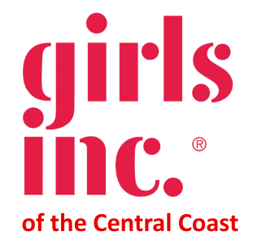
2020 Girls Inc. Sponsorship Opportunities

Sponsorship Level (please mark one)

___ Strong, Smart, & Bold ($5,000)
___ Promote Leadership ($3,000)
___ Encourage Education and College Aspirations ($2,000)
___ Support Girls Health ($1,000)
___ Inspire Mentoring ($500)
Sponsor Information
Contact Name: _________________________________________________________

Organization: __________________________________________________________

Address: ______________________________________________________________

City/State/Zip: _________________________________________________________

Email: ________________________________________________________________

Phone: _______________________________________________________________

Sponsorship listing as: ___________________________________________________

Check payable to: Girls Inc. of the Central Coast

Please send form and check to: Patty Fernandez
Executive Director
318 Cayuga St, Suite 206
Salinas, CA 93901
pfernandez@girlsinccc.org

Send logo and website link to: pfernandez@girlsinccc.org
Please send your logo file in EPS Vector and JPEG format

Girls Inc. of the Central Coast is a 501(c)(3) nonprofit organization. Your sponsorship is tax deductible to the extent allowed by law. Tax ID #20-5040398

Thank you for your support!

